Preventing and responding to bullying

CLERMONT STATE HIGH SCHOOL
ANTI-BULLYING & HARASSMENT POLICY

Clermont State High School is firstly a place of learning in an inclusive environment. We value being respectful, achieving and responsible citizens. Our school is focused on individual achievement, student wellbeing, leadership and celebration of success. We know at Clermont State High School that student learning and thriving are enhanced when students, staff and parents feel connected to others and experience positive safe relationships. We know that focusing on the wellbeing of our students enhances self-esteem, attendance and behaviour, and leads to overall long-term social and emotional outcomes that see our students thriving.

What is bullying, including online bullying?
Bullying is an ongoing and deliberate misuse of power in relationships. The national definition of bullying for Australian schools is:
- ongoing and deliberate misuse of power in relationships through repeated verbal, physical and/or social behaviour that intends to cause physical, social and/or psychological harm;
- involving an individual or a group misusing their power, or perceived power, over one or more persons who feel unable to stop it from happening;
- happening in person or online, via various digital platforms and devices and it can be obvious (overt) or hidden (covert). Bullying behaviour is repeated, or has the potential to be repeated, over time (for example, through sharing of digital records);
- having immediate, medium and long-term effects on those involved, including bystanders. Single incidents and conflict or fights between equals, whether in person or online, are not defined as bullying.

At Clermont State High School we believe that no one deserves to be mistreated and that everyone regardless of race, colour, religion, immigration status, nationality, size, gender, popularity, athletic capability, academic outcomes, social ability, or intelligence has the right to feel safe, secure, and respected.

Management of Bullying including cyber bullying.
It is expected all individuals will report any alleged incident of bullying and or harassment to a staff member immediately. Retaliation of any type is not acceptable. Any unreported incident is a breach of the individual’s responsibility. An investigation into the bullying allegations will then take place with statements from all parties involved, including witness statements. The outcome from these statements will then be acted on immediately. This could include a mediation between parties or in severe circumstances suspension or police intervention. Clermont State High School is a STYMIE school and students are encouraged to use www.stymie.com.au to report any harm that they or any other student is experiencing. This website is an anonymous way that students and parents can stand up for our young people with all reports gong directly to the student’s Year Level HoD.

BEHAVIOUR | SCHOOL ACTION | WHO MAY BE INVOLVED
Low level bullying/harassment  e.g. a passing nasty comment on the way to a class | First offence: warning and incident report (recorded), parental contact | Students  Family members  Staff
Repeated/increased bullying or harassment by the same person, or their friends | Second offence: afterschool detention and parental contact  Subsequent offence: suspension and where necessary, police intervention | Students  Family members  Staff  Administration  Possibly police

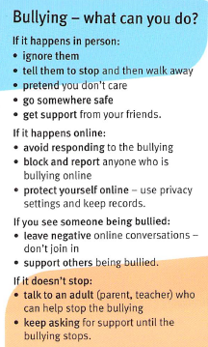
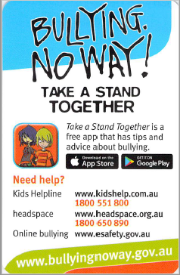

At Clermont State High School we have many different people who can support students in their learning, to promote strategies to improve student wellbeing, safety and learning outcomes.
